Palak Gandhi

[Msc IT - 2020-2022]



**Deep Learning** - Practicals

## Practical no. 1

Performing matrix multiplication and finding eigen vectors and eigen values using TensorFlow

|  |
| --- |
|  |
|  |
|  |
|  |
|  |
|  |
|  |
|  |

## A] Matrix multiplication using TensorFlow:

### Input:

import tensorflow as tf

print("Matrix Multiplication Demo") x=tf.constant([1,2,3,4,5,6],shape=[2,3]) print(x) y=tf.constant([7,8,9,10,11,12],shape=[3,2]) print(y)

z=tf.matmul(x,y) print("Product:",z)

### Output:

Matrix Multiplication Demo

tf.Tensor(

[[1 2 3]

[4 5 6]], shape=(2, 3), dtype=int32)

tf.Tensor(

[[ 7 8]

[ 9 10]

[11 12]], shape=(3, 2), dtype=int32)

Product: tf.Tensor(

[[ 58 64]

[139 154]], shape=(2, 2), dtype=int32)

## B] Finding eigen vectors and eigen values usingTensorFlow:

What are eigenvectors and eigenvalues?

Suppose that we have a matrix A with the following entries:

A=[2 0 0 −1].

If we apply A to any vector v=[x,y]𝖳, we obtain a vector Av=[2x, −y]𝖳. This has an intuitive interpretation: stretch the vector to be twice as wide in the x-direction, and then flip it in the y-direction.

However, there are some vectors for which something remains unchanged. Namely [1,0]𝖳 gets sent to [2,0]𝖳 and [0,1]𝖳 gets sent to [0,−1]𝖳. These vectors are still in the same line, and the only modification is that the matrixstretches them by a factor of 2 and −1 respectively. We call such

vectors eigenvectors and the factor they are stretched by eigenvalues. In general if we can find a number λ and a vector v such that

Av=λv.

We say that v is an eigenvector for A and λ is an eigenvalue.

### Input:

import tensorflow as tf

e_matrix_A = tf.random.uniform([2, 2], minval=3, maxval=10, dtype=tf.float32, name="matrixA")

print("Matrix A: \n{}\n\n".format(e_matrix_A)) eigen_values_A, eigen_vectors_A = tf.linalg.eigh(e_matrix_A)

print("Eigen Vectors: \n{} \n\nEigen Values: \n{}\n".format(eigen_vectors_A, eigen_values_A))

### Output:

Matrix A:

[[8.706659 3.7283762]

[6.0555005 8.069747 ]]

Eigen Vectors:

[[-0.6882888 0.72543675]

[ 0.72543675 0.6882888 ]]

Eigen Values:

[ 2.3243346 14.452071

# Practical No:2

|  |
| --- |
|  |
|  |
|  |
|  |
|  |
|  |
|  |
|  |

## Aim: Solving XOR problem using deep feed forward network.

### Input:

import numpy as np

from keras.layers import Dense

from keras.models import Sequential model=Sequential()

model.add(Dense(units=2,activation='relu',input_dim=2)) model.add(Dense(units=1,activation='sigmoid')) model.compile(loss='binary_crossentropy',optimizer='adam',metrics=['accuracy']) print(model.summary())

print(model.get_weights()) X=np.array([[0.,0.],[0.,1.],[1.,0.],[1.,1.]]) Y=np.array([0.,1.,1.,0.])

model.fit(X,Y,epochs=1000,batch_size=4) print(model.get_weights()) print(model.predict(X,batch_size=4))

### Output:

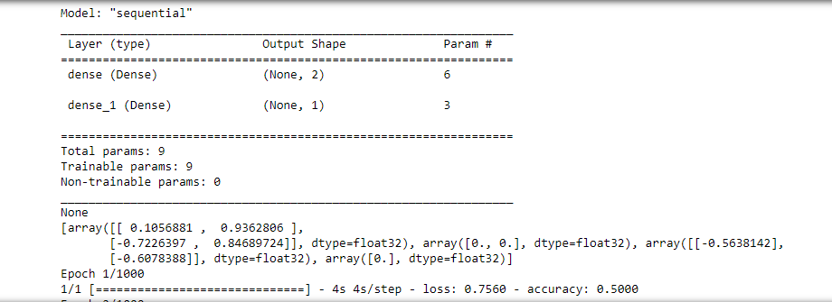

# Practical No:3

## Aim: Implementing deep neural network for performing classification task. Problem statement: the given dataset comprises of health information about diabetic women patient. we need to create deep feed forward network that will classify women suffering from diabetes mellitus as 1.

### Input:

from numpy

import loadtxt

from keras.models

import Sequential

from keras.layers import Dense

dataset=loadtxt(‘pima-indians-diabetes.csv’,delimiter=’,’) dataset

X=dataset[:,0:8] Y=dataset[:,8] model=sequential()

model.add(Dense(12,input_dim=8,activation=’relu’)) model.add(Dense(8,activation=’relu’)) model.add(Dense(1,activation=’sigmoid’))

model.compile(loss=’binary_crossentropy’,optimizer=’adam’,metrics=[‘accuracy’]) model.fit(X,Y,epochs=150,batch_size=10)

_,accuracy=model.evaluate(X,Y) print(‘accuracy of model is ’,(accuracy*100)) prediction=model.predict(X)

for I in range(5): print(X[i].tolist(),prediction[i],Y[i])”)

### Output:

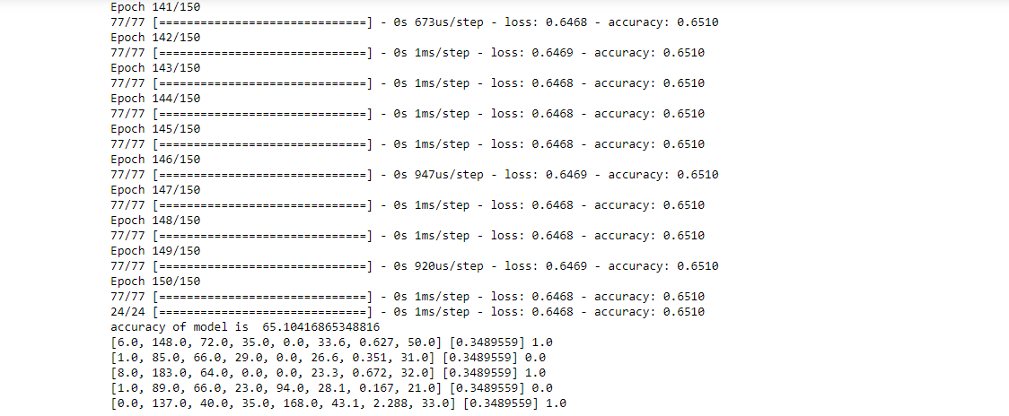

# Practical No:4

Theory:

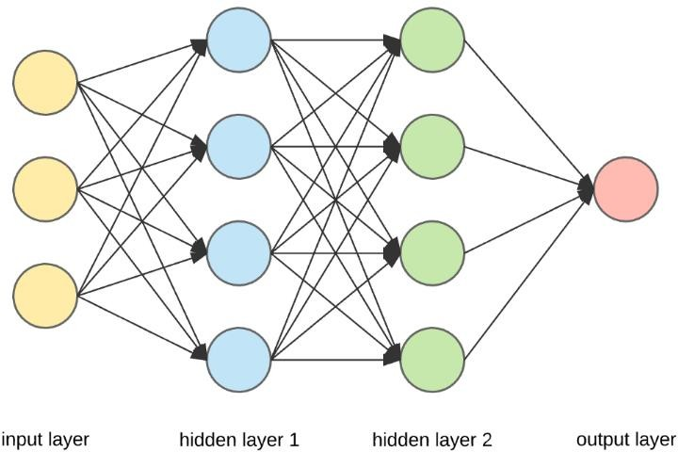

Components:

1. Input Layers,
2. Neurons,
3. Weights,
4. Hidden Layers and
5. Output Layer

|  |
| --- |
|  |
|  |
|  |
|  |
|  |
|  |
|  |
|  |

The activation function is a non-linear transformation that we do over the input before sending it to the next layer of neurons or finalizing it as output.

Several different types of activation functions are used in Deep Learning. Some of them are explained below:

1. Sigmoid 1 1+𝑒𝑥

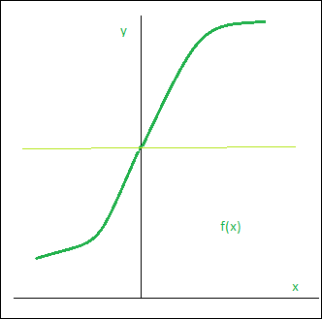

1. Rectified Linear Unit

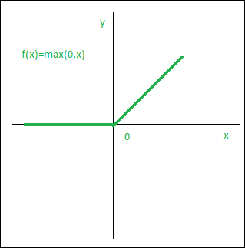f(x) = max {0, x}

### Aim: Using deep feed forward network with two hidden layers for performing classification and predicting the class.

### Input:

from keras.models

import Sequential

from keras.layers import Dense

from sklearn.datasets

import make_blobs

from sklearn.preprocessing

import MinMaxScaler X,Y=make_blobs(n_samples=100,centers=2,n_features=2,random_state=1) scalar=MinMaxScaler()

scalar.fit(X) X=scalar.transform(X)

model=Sequential()

model.add(Dense(4,input_dim=2,activation='relu')) model.add(Dense(4,activation='relu'))

model.add(Dense(1,activation='sigmoid')) model.compile(loss='binary_crossentropy',optimizer='adam') model.fit(X,Y,epochs=500)

Xnew,Yreal=make_blobs(n_samples=3,centers=2,n_features=2,random_state=1) Xnew=scalar.transform(Xnew)

Ynew=model.predict(Xnew)

for i in range(len(Xnew)):

print("X=%s,Predicted=%s,Desired=%s"%(Xnew[i],Ynew[i],Yreal[i]))

### Output:

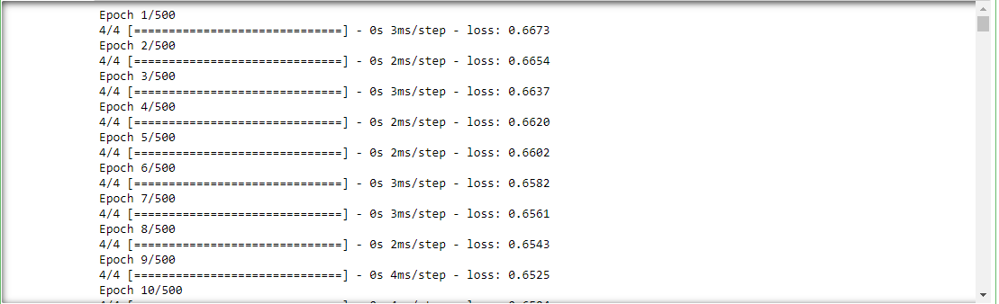

### b.Aim: Using a deep field forward network with two hidden layers for performing classification and predicting the probability of class.

### Input:

from keras.models import Sequential from keras.layers import Dense

from sklearn.datasets import make_blobs

from sklearn.preprocessing import MinMaxScaler X,Y=make_blobs(n_samples=100,centers=2,n_features=2,random_state=1) scalar=MinMaxScaler()

scalar.fit(X) X=scalar.transform(X) model=Sequential()

model.add(Dense(4,input_dim=2,activation='relu')) model.add(Dense(4,activation='relu')) model.add(Dense(1,activation='sigmoid')) model.compile(loss='binary_crossentropy',optimizer='adam') model.fit(X,Y,epochs=500)

Xnew,Yreal=make_blobs(n_samples=3,centers=2,n_features=2,random_state=1)

Xnew=scalar.transform(Xnew) Yclass=model.predict_classes(Xnew) Ynew=model.predict_proba(Xnew) for i in range(len(Xnew)):

print("X=%s,Predicted_probability=%s,Predicted_class=%s"%(Xnew[i],Ynew[i],Ycla ss[i]))

### Output:

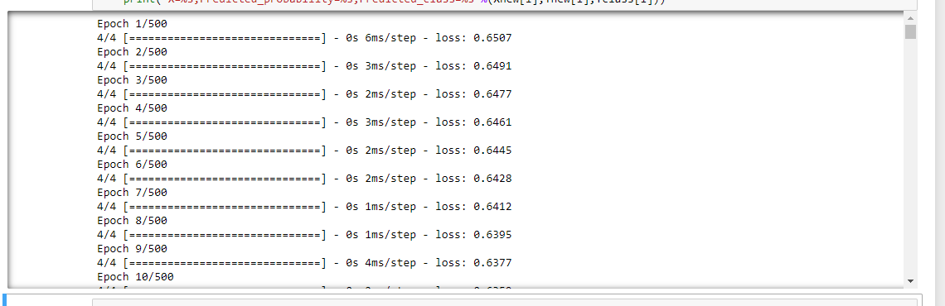

### c.Aim: Using a deep field forward network with two hidden layers for performing linear regression and predicting values.

### Input:

from keras.models import Sequential from keras.layers import Dense

from sklearn.datasets import make_regression from sklearn.preprocessing import MinMaxScaler

X,Y=make_regression(n_samples=100,n_features=2,noise=0.1,random_state=1) scalarX,scalarY=MinMaxScaler(),MinMaxScaler()

scalarX.fit(X) scalarY.fit(Y.reshape(100,1)) X=scalarX.transform(X) Y=scalarY.transform(Y.reshape(100,1)) model=Sequential()

model.add(Dense(4,input_dim=2,activation='relu')) model.add(Dense(4,activation='relu')) model.add(Dense(1,activation='sigmoid')) model.compile(loss='mse',optimizer='adam') model.fit(X,Y,epochs=1000,verbose=0)

Xnew,a=make_regression(n_samples=3,n_features=2,noise=0.1,random_state=1) Xnew=scalarX.transform(Xnew)

Ynew=model.predict(Xnew) for i in range(len(Xnew)):

print("X=%s,Predicted=%s"%(Xnew[i],Ynew[i]))

### Output:

X=[0.29466096 0.30317302],Predicted=[0.18070486]

X=[0.39445118 0.79390858],Predicted=[0.75907624]

X=[0.02884127 0.6208843 ],Predicted=[0.3940779]

# Practical No:5

|  |
| --- |
|  |
|  |
|  |
|  |
|  |
|  |
|  |
|  |

## a.Aim: Evaluating feed forward deep network for regression using KFold cross validation.

### Input:

import pandas as pd

from keras.models

import Sequential

from keras.layers import Dense

from keras.wrappers.scikit_learn

import KerasRegressor

from sklearn.model_selection

import cross_val_score

from sklearn.model_selection

import KFold

from sklearn.preprocessing

import StandardScaler

from sklearn.pipeline import Pipeline

dataframe=pd.read_csv("housing.csv",delim_whitespace=True,header=None) dataset=dataframe.values

X=dataset[:,0:13] Y=dataset[:,13] def wider_model():

model=Sequential() model.add(Dense(15,input_dim=13,kernel_initializer='normal',activation='relu')) model.add(Dense(13,kernel_initializer='normal',activation='relu')) model.add(Dense(1,kernel_initializer='normal')) model.compile(loss='mean_squared_error',optimizer='adam')

return model estimators=[]

estimators.append(('standardize',StandardScaler())) estimators.append(('mlp',KerasRegressor(build_fn=wider_model,epochs=100,batch_si ze=5)))

pipeline=Pipeline(estimators) kfold=KFold(n_splits=10) results=cross_val_score(pipeline,X,Y,cv=kfold)

print("Wider: %.2f (%.2f) MSE" % (results.mean(), results.std()))

### output:

(After changing neuron)

model.add(Dense(20, input_dim=13,kernel_initializer='normal',activation='relu'))

## b.Aim: Evaluating feed forward deep network for multiclass Classification using KFold cross-validation.

### Input:

#loading libraries import pandas

from keras.models import Sequential from keras.layers import Dense

from keras.wrappers.scikit_learn import KerasClassifier from keras.utils import np_utils

from sklearn.model_selection import cross_val_score from sklearn.model_selection import KFold

from sklearn.preprocessing import LabelEncoder #loading dataset df=pandas.read_csv('flowers.csv',header=None) print(df)

#splitting dataset into input and output variables X = df.iloc[:,0:4].astype(float)

y=df.iloc[:,4] #print(X) #print(y)

#encoding string output into numeric output encoder=LabelEncoder()

encoder.fit(y) encoded_y=encoder.transform(y) print(encoded_y) dummy_Y=np_utils.to_categorical(encoded_y) print(dummy_Y)

def baseline_model():

# create model model = Sequential()

model.add(Dense(8, input_dim=4, activation='relu')) model.add(Dense(3, activation='softmax'))

# Compile model

model.compile(loss='categorical_crossentropy', optimizer='adam', metrics=['accuracy']) return model

estimator=baseline_model() estimator.fit(X,dummy_Y,epochs=100,shuffle=True) action=estimator.predict(X)

for i in range(25): print(dummy_Y[i]) print('^^^^^^^^^^^^^^^^^^^^^^') for i in range(25): print(action[i])

### Output:

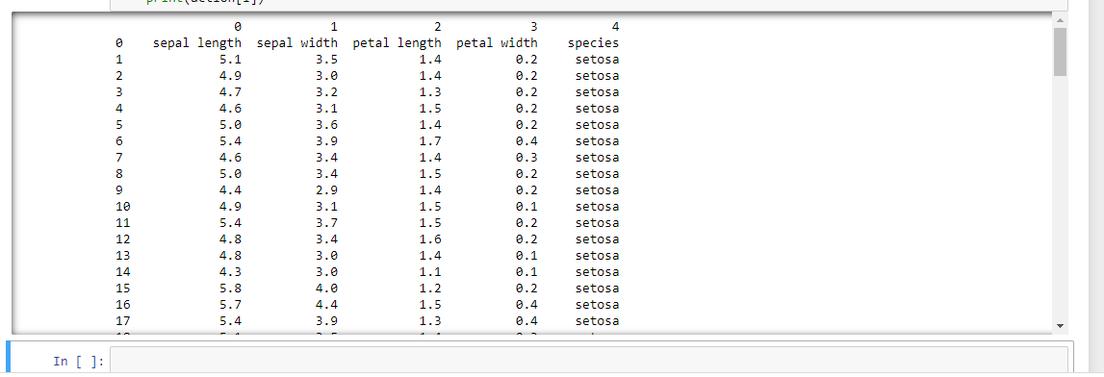

# Practical No :6

|  |
| --- |
|  |
|  |
|  |
|  |
|  |
|  |
|  |
|  |

## Aim: implementing regularization to avoid overfitting in binary classification. Theory:

Overfitting and regularization are the most common terms which are heard in [Machine learning](https://dataaspirant.com/category/machine-learning-2/) and Statistics. Your model is said to be overfitting if it performs very well on the training data but fails to perform well on unseen data.

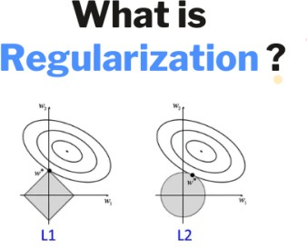This is one of the most common and dangerous phenomena that occurs when [training your machine](https://dataaspirant.com/support-vector-machine-classifier-implementation-r-caret-package/) [learning models](https://dataaspirant.com/support-vector-machine-classifier-implementation-r-caret-package/). There are many techniques that you can use to fix this problem. Regularization is one among them.

Regularization, as the name suggests, is the process of regularizing something. Regularization shrinks the parameters of the model to zero, which reduces its freedom.

Hence, the model will be less likely to fit the noise of training data and will improve the generalization ability of the model.

We penalize the [cost function](https://dataaspirant.com/optimization-algorithms-deep-learning/) by adding a penalty that regularizes or shrinks the coefficient estimates to zero.

Let’s look at the cost function

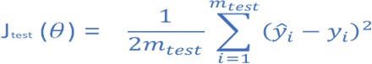

where

* hθ(x(i)) is the predicted value of some datapoint x(i)
* y(i) is original

The penalized cost function looks like this

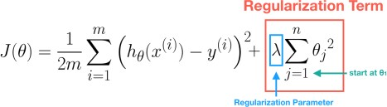

where-

* λ is the tuning parameter that decides how much we want to penalize the flexibility of our model. It can be tuned using cross-validation.

So each time some parameter tries to become large, it will be penalized to a small value. There are two kinds of regularization:

* L1 Regularization
* L2 Regularization

L1 Regularization

This adds a penalty equal to the L1 norm of the weights vector(sum of the absolute value of the coefficients). It will shrink some parameters to zero.

Hence some variables will not play any role in the model. L1 regression can be seen as a way to select features in a model.

L1 = L(X,y) + λ|θ|

L2 Regularization

This adds a penalty equal to the L2 norm of the weights vector(sum of the squared values of the coefficients). It will force the parameters to be relatively small.

L2 = L(X,y) + λθ2

### Input:

from matplotlib

import pyplot

from sklearn.datasets

import make_moons from keras.models

import Sequential from keras.layers

import Dense

X,Y=make_moons(n_samples=100,noise=0.2,random_state=1) n_train=30

trainX,testX=X[:n_train,:],X[n_train:] trainY,testY=Y[:n_train],Y[n_train:] #print(trainX)

#print(trainY) #print(testX) #print(testY) model=Sequential()

model.add(Dense(500,input_dim=2,activation='relu')) model.add(Dense(1,activation='sigmoid')) model.compile(loss='binary_crossentropy',optimizer='adam',metrics=['accuracy']) history=model.fit(trainX,trainY,validation_data=(testX,testY),epochs=4000) pyplot.plot(history.history['accuracy'],label='train') pyplot.plot(history.history['val_accuracy'],label='test')

pyplot.legend() pyplot.show()

### Ouput:

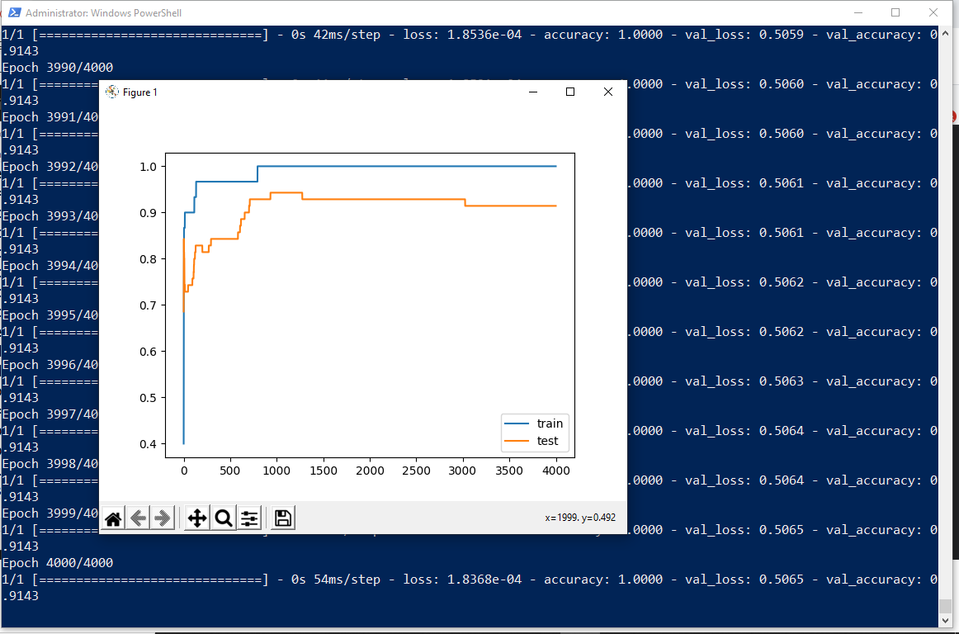

The above code and resultant graph demonstrate overfitting with accuracy of testing data less than accuracy of training data also the accuracy of testing data increases once and then start decreases gradually.to solve this problem we can use regularization

Hence, we will add two lines in the above code as highlighted below to implement l2 regularization with alpha=0.001

### Input:

from matplotlib import pyplot

from sklearn.datasets import make_moons

from keras.models import Sequential

from keras.layers import Dense

from keras.regularizers import l2 #its L2 not twelve X,Y=make_moons(n_samples=100,noise=0.2,random_state=1)

n_train=30

trainX,testX=X[:n_train,:],X[n_train:] trainY,testY=Y[:n_train],Y[n_train:] #print(trainX)

#print(trainY)

#print(testX)

#print(testY)

model=Sequential()

model.add(Dense(500,input_dim=2,activation='relu',kernel_regularizer=l2(0.001)))

model.add(Dense(1,activation='sigmoid')) model.compile(loss='binary_crossentropy',optimizer='adam',metrics=['accuracy']) history=model.fit(trainX,trainY,validation_data=(testX,testY),epochs=4000) pyplot.plot(history.history['accuracy'],label='train') pyplot.plot(history.history['val_accuracy'],label='test')

pyplot.legend() pyplot.show()

### Ouput:

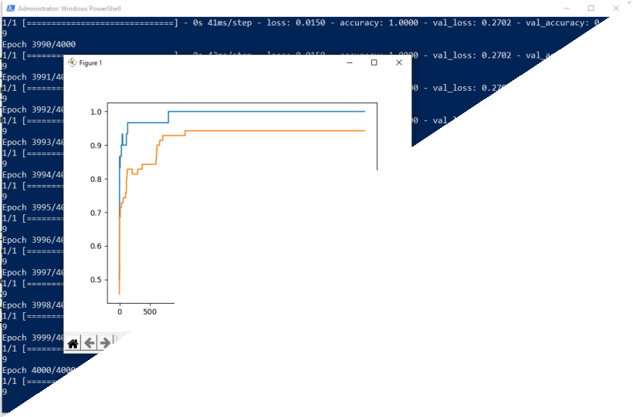

By replacing l2 (L2) regularizer with l1(L1) regularizer at the same learning rate 0.001 we get the following output.

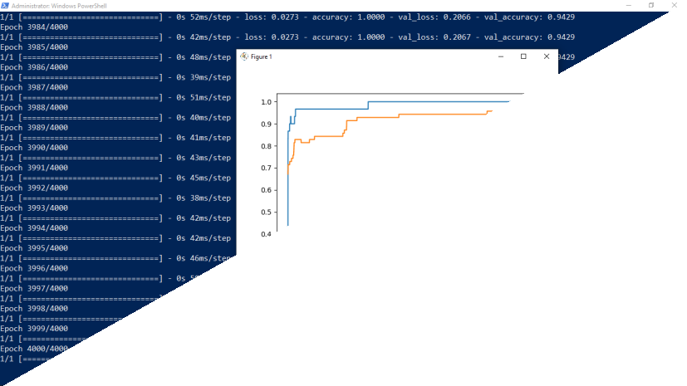

By applying l1 and l2 regularizer we can observe the following changes in accuracy of both trainig and testing data. The changes in code are also highlighted.

### Input:

from matplotlib import pyplot

from sklearn.datasets import make_moons

from keras.models import Sequential

from keras.layers import Dense

from keras.regularizers import l1_l2 X,Y=make_moons(n_samples=100,noise=0.2,random_state=1) n_train=30

trainX,testX=X[:n_train,:],X[n_train:]

trainY,testY=Y[:n_train],Y[n_train:] #print(trainX)

#print(trainY) #print(testX) #print(testY) model=Sequential()

model.add(Dense(500,input_dim=2,activation='relu',kernel_regularizer=l1_l2(l1=0.00 1,l2=0.001)))

model.add(Dense(1,activation='sigmoid')) model.compile(loss='binary_crossentropy',optimizer='adam',metrics=['accuracy']) history=model.fit(trainX,trainY,validation_data=(testX,testY),epochs=4000) pyplot.plot(history.history['accuracy'],label='train') pyplot.plot(history.history['val_accuracy'],label='test')

pyplot.legend()

pyplot.show()

### Output:

## Practical No:7

|  |
| --- |
|  |
|  |
|  |
|  |
|  |
|  |
|  |
|  |

### Aim: Demonstrate recurrent neural network that learns to perform sequence analysis for stock price.

### Input:

import numpy as np

import matplotlib.pyplot as plt import pandas as pd

from keras.models import Sequential

from keras.layers import Dense

from keras.layers import LSTM

from keras.layers import Dropout

from sklearn.preprocessing

import MinMaxScaler dataset_train=pd.read_csv('Google_Stock_price_train.csv') #print(dataset_train) training_set=dataset_train.iloc[:,1:2].values #print(training_set) sc=MinMaxScaler(feature_range=(0,1)) training_set_scaled=sc.fit_transform(training_set)

#print(training_set_scaled)

X_train=[] Y_train=[]

for i in range(60,1258): X_train.append(training_set_scaled[i-60:i,0]) Y_train.append(training_set_scaled[i,0]) X_train,Y_train=np.array(X_train),np.array(Y_train) print(X_train)

print('*********************************************') print(Y_train) X_train=np.reshape(X_train,(X_train.shape[0],X_train.shape[1],1)) print('**********************************************') print(X_train)

regressor=Sequential() regressor.add(LSTM(units=50,return_sequences=True,input_shape=(X_train.shape[1], 1)))

regressor.add(Dropout(0.2)) regressor.add(LSTM(units=50,return_sequences=True)) regressor.add(Dropout(0.2)) regressor.add(LSTM(units=50,return_sequences=True)) regressor.add(Dropout(0.2)) regressor.add(LSTM(units=50)) regressor.add(Dropout(0.2)) regressor.add(Dense(units=1))

regressor.compile(optimizer='adam',loss='mean_squared_error') regressor.fit(X_train,Y_train,epochs=100,batch_size=32) dataset_test=pd.read_csv('Google_Stock_price_Test.csv')

real_stock_price=dataset_test.iloc[:,1:2].values dataset_total=pd.concat((dataset_train['Open'],dataset_test['Open']),axis=0) inputs=dataset_total[len(dataset_total)-len(dataset_test)-60:].values inputs=inputs.reshape(-1,1)

inputs=sc.transform(inputs) X_test=[]

for i in range(60,80):

X_test.append(inputs[i-60:i,0]) X_test=np.array(X_test)

X_test=np.reshape(X_test,(X_test.shape[0],X_test.shape[1],1)) predicted_stock_price=regressor.predict(X_test) predicted_stock_price=sc.inverse_transform(predicted_stock_price) plt.plot(real_stock_price,color='red',label='real google stock price') plt.plot(predicted_stock_price,color='blue',label='predicted stock price') plt.xlabel('time')

plt.ylabel('google stock price') plt.legend()

plt.show()

### Output:

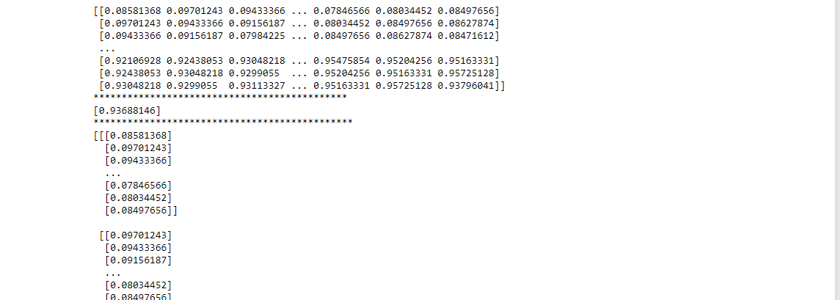

# Practical No:8

## Aim: Performing encoding and decoding of images using deep autoencoder.

|  |
| --- |
|  |
|  |
|  |
|  |
|  |
|  |
|  |
|  |

### Input:

import keras

from keras import layers

from keras.datasets

import mnist

import numpy as np encoding_dim=32

#this is our input image input_img=keras.Input(shape=(784,))

#"encoded" is the encoded representation of the input encoded=layers.Dense(encoding_dim, activation='relu')(input_img) #"decoded" is the lossy reconstruction of the input decoded=layers.Dense(784, activation='sigmoid')(encoded) #creating autoencoder model autoencoder=keras.Model(input_img,decoded)

#create the encoder model encoder=keras.Model(input_img,encoded) encoded_input=keras.Input(shape=(encoding_dim,)) #Retrive the last layer of the autoencoder model decoder_layer=autoencoder.layers[-1]

#create the decoder model decoder=keras.Model(encoded_input,decoder_layer(encoded_input)) autoencoder.compile(optimizer='adam',loss='binary_crossentropy') #scale and make train and test dataset (X_train,_),(X_test,_)=mnist.load_data() X_train=X_train.astype('float32')/255.

X_test=X_test.astype('float32')/255. X_train=X_train.reshape((len(X_train),np.prod(X_train.shape[1:]))) X_test=X_test.reshape((len(X_test),np.prod(X_test.shape[1:]))) print(X_train.shape)

print(X_test.shape)

#train autoencoder with training dataset autoencoder.fit(X_train,X_train, epochs=50,

batch_size=256, shuffle=True,

validation_data=(X_test,X_test)) encoded_imgs=encoder.predict(X_test) decoded_imgs=decoder.predict(encoded_imgs)

import matplotlib.pyplot as plt

n = 10 # How many digits we will display

plt.figure(figsize=(40, 4))

for i in range(10):

# display original

ax = plt.subplot(3, 20, i + 1)

plt.imshow(X_test[i].reshape(28, 28))

plt.gray()

ax.get_xaxis().set_visible(False)

ax.get_yaxis().set_visible(False)

# display encoded image

ax = plt.subplot(3, 20, i + 1 + 20)

plt.imshow(encoded_imgs[i].reshape(8,4))

plt.gray()

ax.get_xaxis().set_visible(False)

ax.get_yaxis().set_visible(False) # display reconstruction

ax = plt.subplot(3, 20, 2*20 +i+ 1)

plt.imshow(decoded_imgs[i].reshape(28, 28))

plt.gray()

ax.get_xaxis().set_visible(False)

ax.get_yaxis().set_visible(False) plt.show()

### Output:

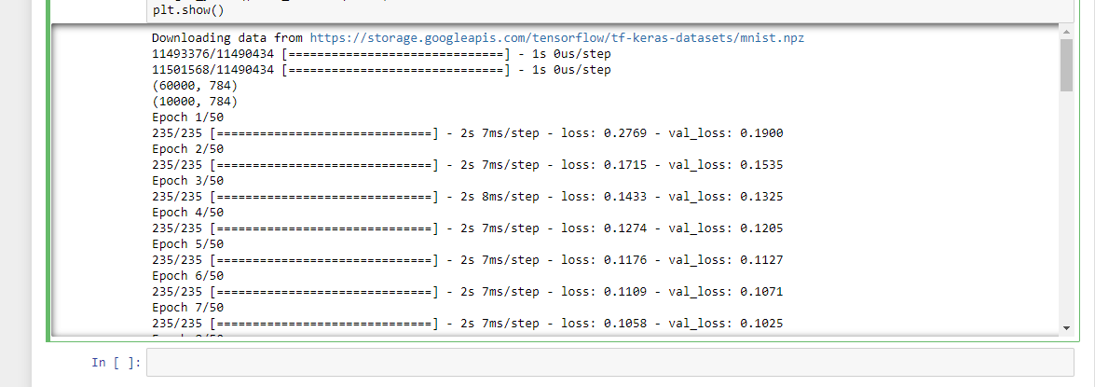

## Practical no. 9

### Implementation of convolutional neural network topredict numbers from number images:

Theory:

|  |
| --- |
|  |
|  |
|  |
|  |
|  |
|  |
|  |
|  |

### Input:

from keras.datasets

import mnist from keras.utils

import to_categorical from keras.models

import Sequential

from keras.layers import Dense,Conv2D,Flatten

import matplotlib.pyplot as plt

#download mnist data and split into train and test sets (X_train,Y_train),(X_test,Y_test)=mnist.load_data() #plot the first image in the dataset plt.imshow(X_train[0])

plt.show() print(X_train[0].shape)

X_train=X_train.reshape(60000,28,28,1)

X_test=X_test.reshape(10000,28,28,1)

Y_train=to_categorical(Y_train)

Y_test=to_categorical(Y_test)

Y_train[0]

print(Y_train[0]) model=Sequential() # add model layers #learn image features

model.add(Conv2D(64,kernel_size=3,activation='relu',input_shape=(28,28,1))) model.add(Conv2D(32,kernel_size=3,activation='relu'))

model.add(Flatten()) model.add(Dense(10,activation='softmax'))

model.compile(optimizer='adam',loss='categorical_crossentropy',metrics=['accuracy']) #train

model.fit(X_train,Y_train,validation_data=(X_test,Y_test),epochs=3) print(model.predict(X_test[:4]))

#actual results for 1st 4 images in the test set print(Y_test[:4])

## Practical no. 10:

Denoising of images using autoencoder

Building and training an image denoising autoencoder using Keras with Tensorflow 2.0 as a backend.

##### Overview

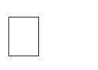 Import Key libraries, dataset and visualize images

 Perform image normalization, pre-processing, and add random noise to images

 Build an Autoencoder using Keras with Tensorflow 2.0 as a backend  Compile and fit Autoencoder model to training data

 Assess the performance of trained Autoencoder using various KPIs Understanding the theory

Autoencoder Intuition

Autoencoders are a type of Artificial Neural Networks that are used to perform a task of data encoding (representation learning). Autoencoders use same input data for input as well as output, crazy right?

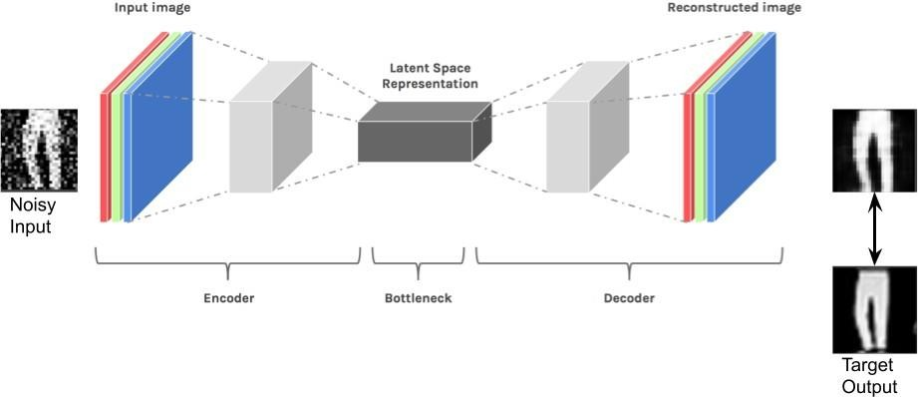

Code Layer

Autoencoders work by adding a bottleneck in the network. This bottleneck forces the network to create a compressed (encoded) version of the original input. Autoencoders work well if correlations exist between input data and (performs poorly if all the input data is independent).

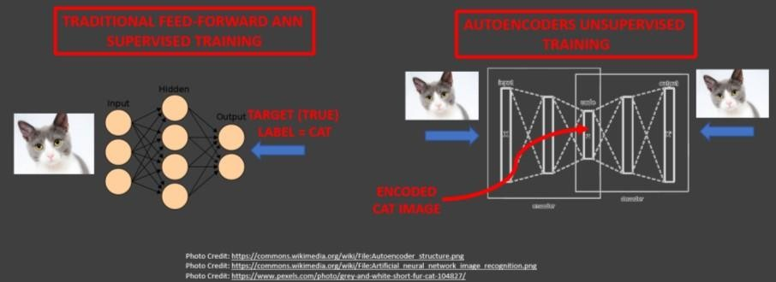

Math behind Autoencoder

Encoder: h(x) = sigmoid (W * x + b) Decoder: x̂ = sigmoid (W* * h(x) + c)

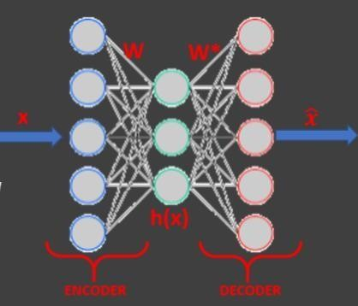

Reconstruction Error

Autoencoders objective is to minimize the reconstruction error which is the difference between the input X and the network output X̂ .

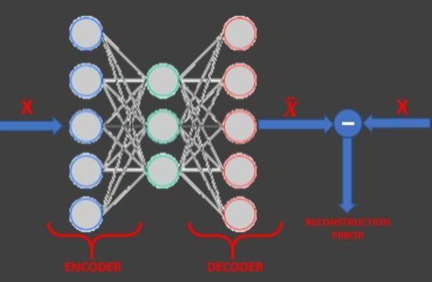

Autoencoders dimensionality reduction (latent space) is quite similar to PCA (Principal Component Analysis) if linear activation functions are used.

##### Step 1

Install following modules using pip:

notebook tensorflow==2.0 pandas

numpy matplotlib seaborn random

for example :

pip install pandas pip install seaborn Step 2

Open jupyter notebook on your local host or you can use Google Colab too.

##### Step 3 Code:

import keras

from keras.datasets import mnist from keras import layers

import numpy as np

from keras.callbacks import TensorBoard import matplotlib.pyplot as plt (X_train,_),(X_test,_)=mnist.load_data() X_train=X_train.astype('float32')/255.

X_test=X_test.astype('float32')/255. X_train=np.reshape(X_train,(len(X_train),28,28,1))

X_test=np.reshape(X_test,(len(X_test),28,28,1)) noise_factor=0.5

X_train_noisy=X_train+noise_factor*np.random.normal(loc=0.0,scale=1.0,size=X_tra in.shape) X_test_noisy=X_test+noise_factor*np.random.normal(loc=0.0,scale=1.0,size=X_test.s hape)

X_train_noisy=np.clip(X_train_noisy,0.,1.) X_test_noisy=np.clip(X_test_noisy,0.,1.) n=10

plt.figure(figsize=(20,2)) for i in range(1,n+1):

ax=plt.subplot(1,n,i) plt.imshow(X_test_noisy[i].reshape(28,28)) plt.gray()

ax.get_xaxis().set_visible(False) ax.get_yaxis().set_visible(False) plt.show() input_img=keras.Input(shape=(28,28,1))

x=layers.Conv2D(32,(3,3),activation='relu',padding='same')(input_img) x=layers.MaxPooling2D((2,2),padding='same')(x) x=layers.Conv2D(32,(3,3),activation='relu',padding='same')(x) encoded=layers.MaxPooling2D((2,2),padding='same')(x) x=layers.Conv2D(32,(3,3),activation='relu',padding='same')(encoded) x=layers.UpSampling2D((2,2))(x) x=layers.Conv2D(32,(3,3),activation='relu',padding='same')(x) x=layers.UpSampling2D((2,2))(x) decoded=layers.Conv2D(1,(3,3),activation='sigmoid',padding='same')(x) autoencoder=keras.Model(input_img,decoded) autoencoder.compile(optimizer='adam',loss='binary_crossentropy') autoencoder.fit(X_train_noisy,X_train,

epochs=3, batch_size=128, shuffle=True,

validation_data=(X_test_noisy,X_test), callbacks=[TensorBoard(log_dir='/tmo/tb',histogram_freq=0,write_graph=False)]) predictions=autoencoder.predict(X_test_noisy)

m=10

plt.figure(figsize=(20,2)) for i in range(1,m+1): ax=plt.subplot(1,m,i)

plt.imshow(predictions[i].reshape(28,28)) plt.gray() ax.get_xaxis().set_visible(False) ax.get_yaxis().set_visible(False) plt.show()